System : Information System

Company/Office : Kean Gabriel Foundation

Project Stage : Logical Database Design and Physical Database Design

Date : 31 July 2017

Class & Section : IT-12 MWF, 9:00AM – 10:00AM

Group Name : trashBin

Group Members : Marc Andrew Betonio, Jhonlloyd Gellica, Reylar Rebuta, and

John Mar Lorenzo

Project Stage : Design

Project Title : Logical Database Design and Physical Database Design

Deadline : 31 July 2017

1. **LOGICAL DATABASE DESIGN**

1.1 **FINAL INPUT SCREENS AND FINAL OUTPUT REPORTS/SCREENS**

1. Login Authentication Form.

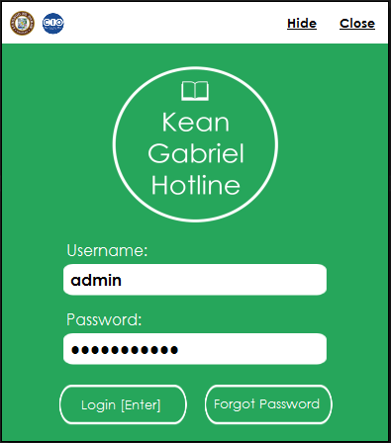

2. Selection Menu

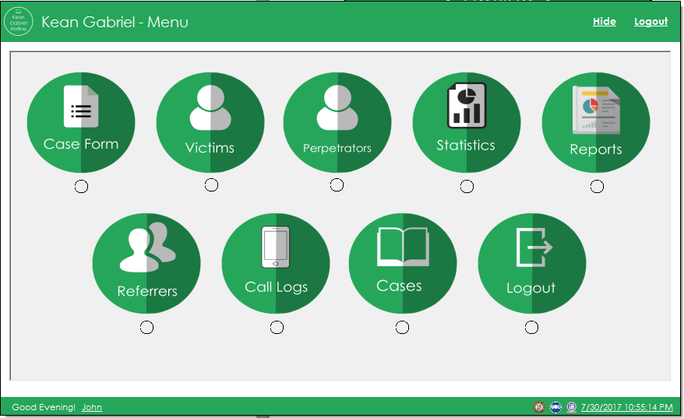

2. Case Form(On Person Reporting tab)

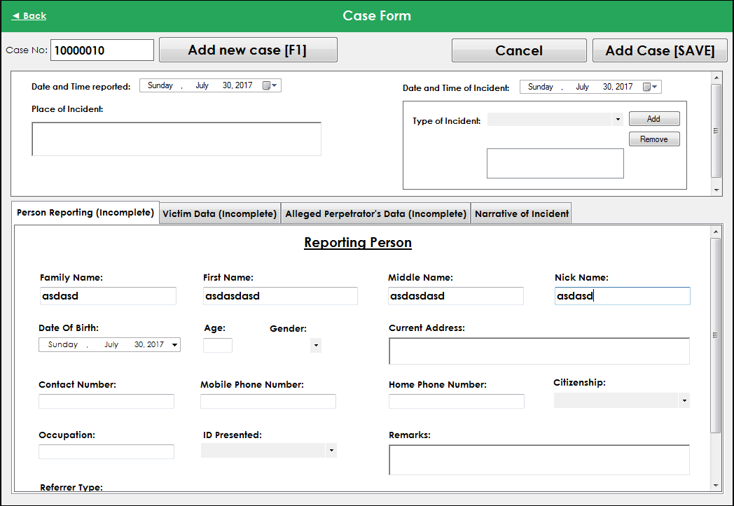

3. Case Form(On Victim Data Tab)

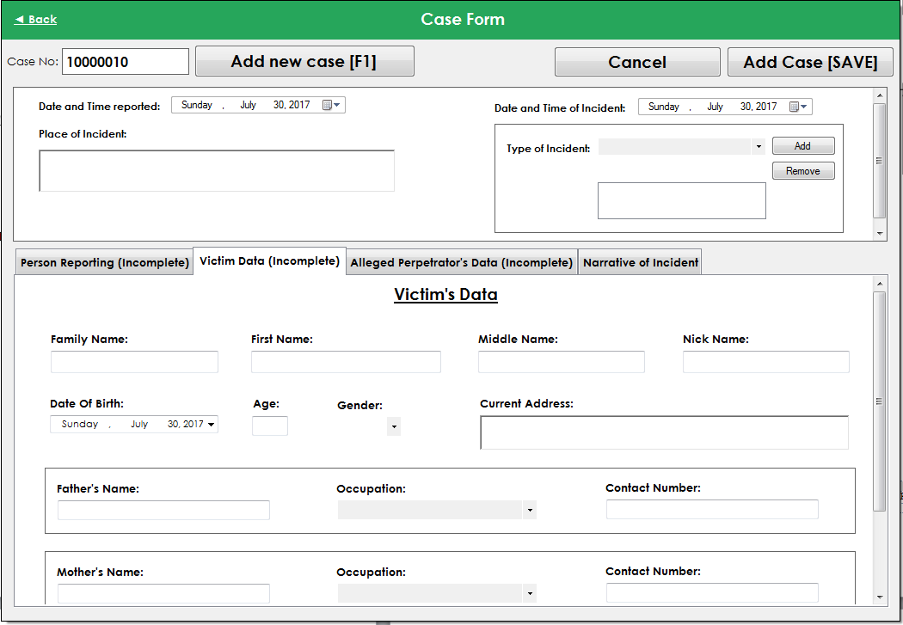

4. Case Form(On Alleged Perpetrator’s Data Tab)

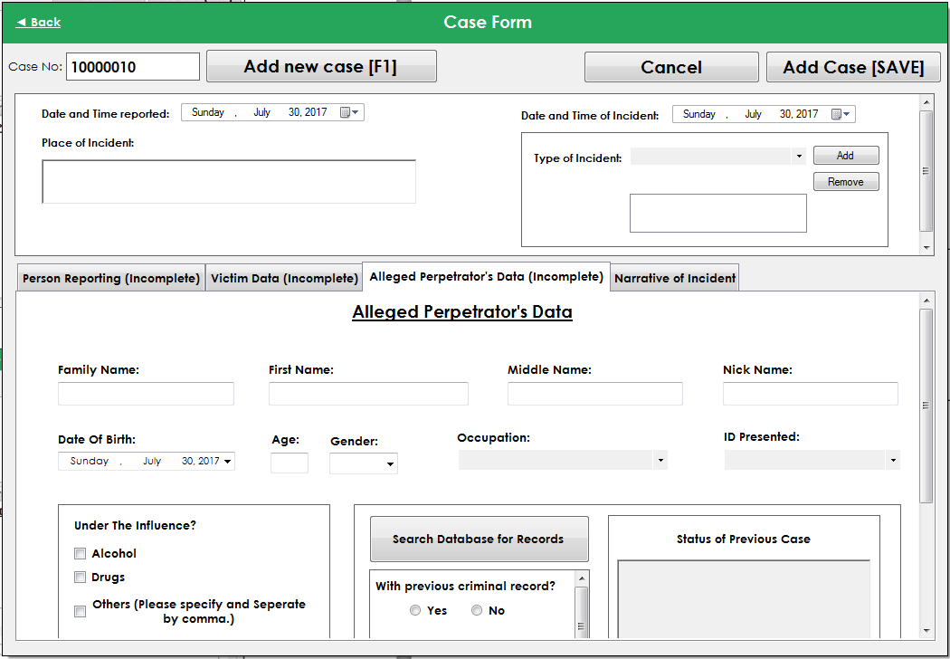

5. Case Form(On Narrative of Incident Tab)

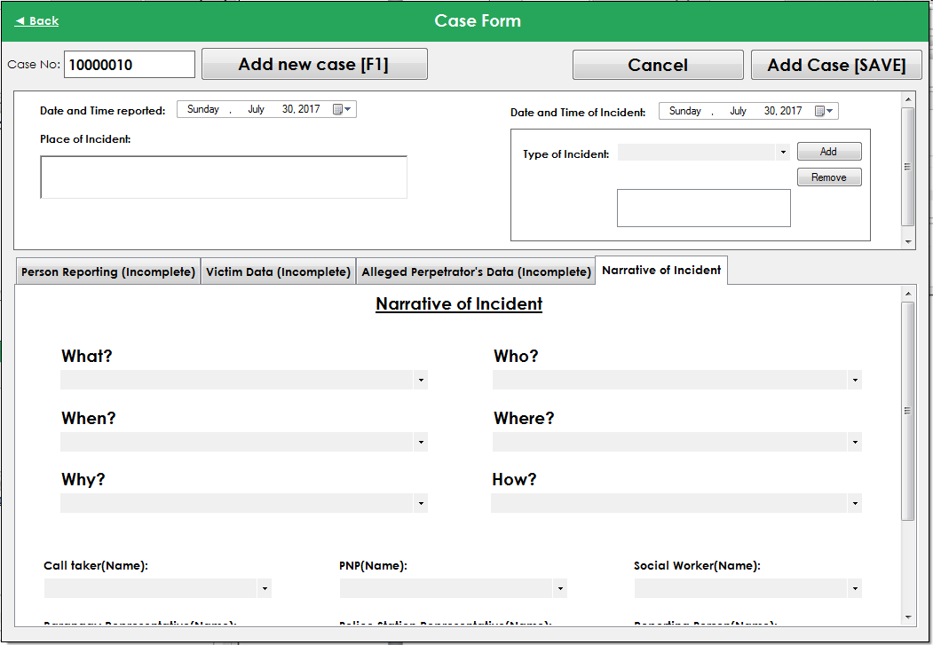

6. Victim Form

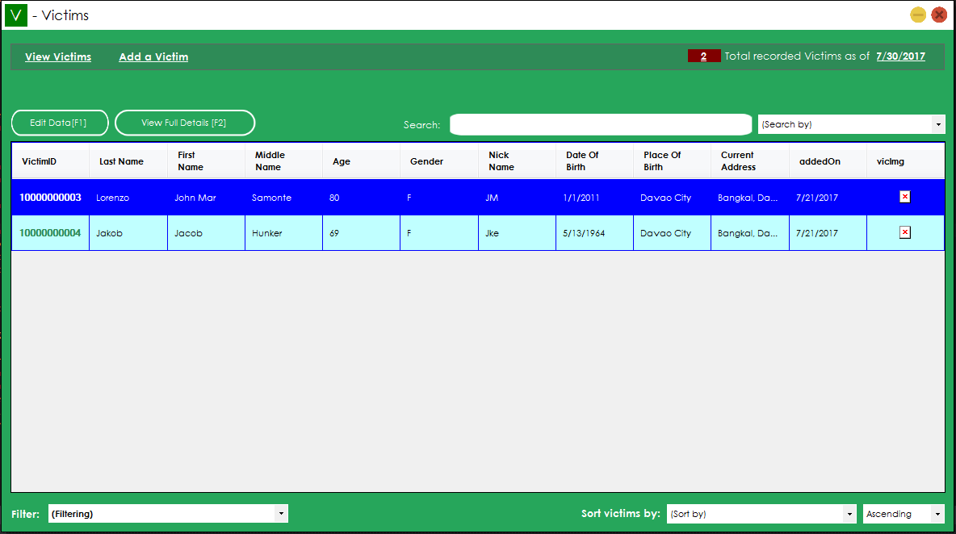

7. Perpetrator’s Form

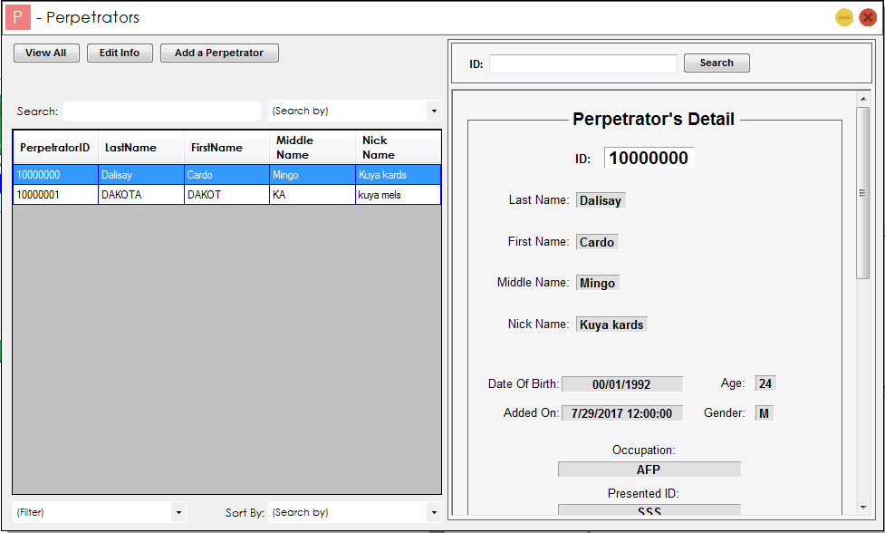

8. Invalid Account Dialog

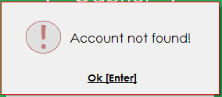

9. Error on database connection Dialog

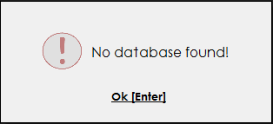

10. Call Logs Form

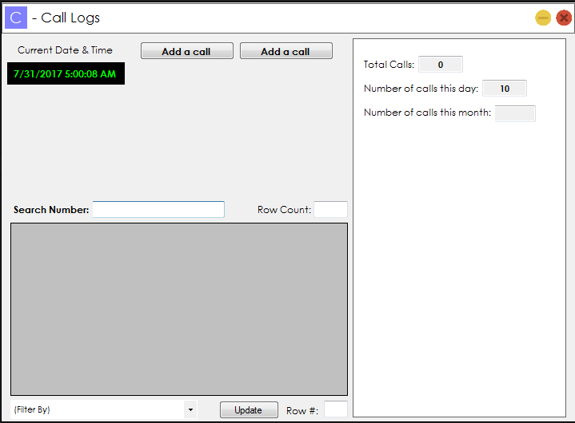

**FINAL ERD**



DATA DICTIONARY

|  |  |  |  |  |  |  |  |  |
| --- | --- | --- | --- | --- | --- | --- | --- | --- |
| **Entity Name (table name): Billing** | | | | | | | | |
| Attribute | Description | Type | Size | Null | Unique | Part_ of_PK | Foreign Key | FK_Relation |
| BillingID | Customer Billing ID | Integer |  | No | Yes | Yes | No |  |
| InvoiceID | Invoice ID | Integer |  | Yes | No | No | Yes | Invoice |
| TotalVat | Total Value added tax | Money |  | Yes | No | No | No |  |
| Total | Total Amount | Money |  | Yes | No | No | No |  |
| DiscountPhp | Discounted Php amount if php is selected as type of discount | Money |  | Yes | No | No | No |  |
| DiscountType | Type of Discount selected | Varchar | 50 | Yes | No | No | No |  |
| DiscountPercent | Discounted Percentage if % is selected as type of discount | Int |  | Yes | No | No | No |  |
|  |  |  |  |  |  |  |  |  |

|  |  |  |  |  |  |  |  |  |
| --- | --- | --- | --- | --- | --- | --- | --- | --- |
| **Entity Name (table name): Clients** | | | | | | | | |
| Attribute | Description | Type | Size | Null | Unique | Part_of_PK | Foreign Key | FK_Relation |
| ClientID | Client’s ID | Integer |  | No | Yes | Yes |  |  |
| ClientName | Client’s Name | Varchar | MAX | Yes | Yes | No |  |  |
| PhoneNum | Client’s Phone Number | BigInt |  | Yes | No | No |  |  |
| Email | Client’s Email | Varchar | MAX | Yes | No | No |  |  |
| DateAdded | Date of Addition of Client | date |  | Yes | No | No |  |  |
| orderCount | Total numbers of client’s transaction | Integer |  | Yes | No | No |  |  |

|  |  |  |  |  |  |  |  |  |
| --- | --- | --- | --- | --- | --- | --- | --- | --- |
| **Entity Name (table name): Inventory** | | | | | | | | |
| Attribute | Description | Type | Size | Null | Unique | Part_of_PK | Foreign Key | FK_Relation |
| StockID | Stock Number | Integer |  | No | Yes | Yes |  |  |
| ItemCode | Item Code | Integer |  | Yes | No | No | Yes | Items |
| Quantity | Total Quantity of Items Available | Integer |  | Yes | No | No | No |  |
| dateAdded | Date the Item was added | Date |  | Yes | No | No | No |  |
| dateUpdated | Date the item was updated | Date |  | Yes | No | No | No |  |
| AddedBy | User who added the item | Varchar | 50 | Yes | No | No | No |  |
| UpdatedBy | User who updated the item | Varchar | 50 | Yes | No | No | No |  |
| Enabled | If item is enabled or not | Varchar | 50 | Yes | No | No | No |  |

|  |  |  |  |  |  |  |  |  |
| --- | --- | --- | --- | --- | --- | --- | --- | --- |
| **Entity Name (table name): Items** | | | | | | | | |
| Attribute | Description | Type | Size | Null | Unique | Part_of_PK | Foreign Key | FK_Relation |
| ItemCode | Item Code | Varchar | 50 | No | Yes | Yes |  |  |
| ItemName | Item Name | Varchar | MAX | Yes | No | No | No |  |
| Category | Item Category | Varchar | 50 | Yes | No | No | No |  |
| Price | Item Price | Money |  | Yes | No | No | No |  |
| NofORDERS | Total number of times the item was ordered | Integer |  | Yes | No | No | No |  |

|  |  |  |  |  |  |  |  |  |
| --- | --- | --- | --- | --- | --- | --- | --- | --- |
| **Entity Name (table name): Invoice** | | | | | | | | |
| Attribute | Description | Type | Size | Null | Unique | Part_  of_PK | FK | FK_Relation |
| InvoiceID | Invoice Number | Integer |  | No | Yes | Yes |  |  |
| ClientID | Client ID | Integer |  | Yes | No | No | Yes | Clients |
| StaffID | Staff ID | Integer |  | Yes | No | No | Yes | Staffs |
| InvoiceDate | Invoice Date | Date |  | Yes | No | No | No |  |

|  |  |  |  |  |  |  |  |  |
| --- | --- | --- | --- | --- | --- | --- | --- | --- |
| **Entity Name (table name): InvoiceDetails** | | | | | | | | |
| Attribute | Description | Type | Size | Null | Unique | Part_  of_PK | FK | FK_Relation |
| InvoiceID | Invoice ID | Integer |  | Yes | No | No | Yes | Invoice |
| ItemCode | Item Code | Varchar | 50 | Yes | No | No | Yes | Items |
| Quantity | Total number of unit | Int |  | Yes | No | No | No |  |
| SubTotal | Sub Total | Money |  | Yes | No | No | No |  |

|  |  |  |  |  |  |  |  |  |
| --- | --- | --- | --- | --- | --- | --- | --- | --- |
| **Entity Name (table name): Payment** | | | | | | | | |
| Attribute | Description | Type | Size | Null | Unique | Part_  of_PK | FK | FK_Relation |
| OrNo | Order Number | Integer |  | No | Yes | Yes | No |  |
| BillingID | Billing ID | Integer |  | Yes | No | No | Yes | Billing |
| payDate | Payment Date | Date |  | Yes | No | No | No |  |
| TotalPay | Total Payment | Money |  | Yes | No | No | No |  |
| Change | Change | Money |  | Yes | No | No | No |  |
| payType | Payment mode | Varchar | 50 | Yes | No | No | No |  |

|  |  |  |  |  |  |  |  |  |
| --- | --- | --- | --- | --- | --- | --- | --- | --- |
| **Entity Name (table name): Staffs** | | | | | | | | |
| Attribute | Description | Type | Size | Null | Unique | Part_  of_PK | FK | FK_Relation |
| StaffID | Staff ID | Integer |  | No | Yes | Yes | Yes | UserAccounts |
| UserName | Staff username | Varchar | 50 | No | Yes | No | No |  |
| PassWord | Staff password | Varchar | 50 | No | No | No | No |  |
| HyBlockStat | If block from logging in status | Varchar | 50 | Yes | No | No | No |  |
| Status | Status if the user is currently logged in or not | Varchar | 50 | Yes | No | No | No |  |

**FINAL NORMALIZED TABLES**

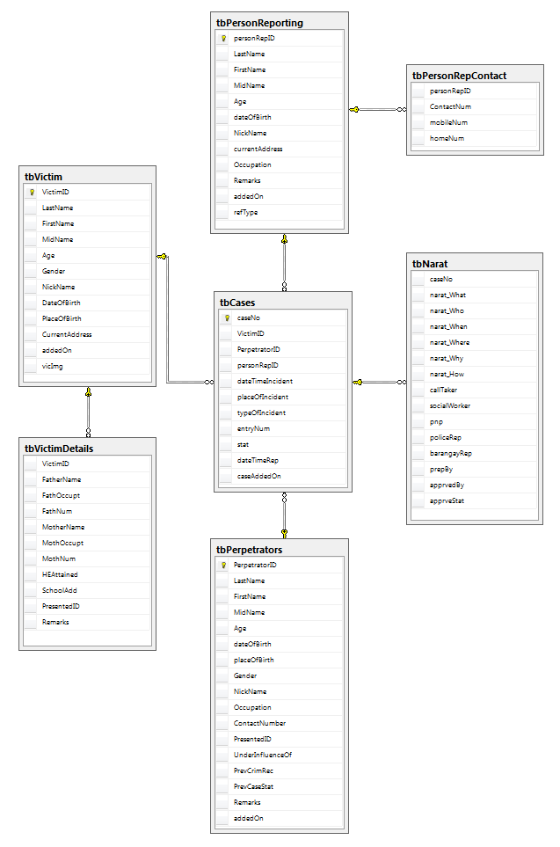

1. **PHYSICAL DATABASE DESIGN**

**INDEXES**

1. **Create Unique Clustered Index for Primary Keys**

Entity Primary Key Attribute Index Name

tbVictim VictimID VictimID_index

tbPerpetrators PerpetratorID PerpetratorID_index

tbPersonReporting personRepID personRepID_index

tbCases caseNo caseNo_index

1. **Create Index for Non-Key Indexes**

Entity Primary Key Attribute Index Name

**REFERENTIAL INTEGRITY**

* **tbPersonReporting & tbPersonRepContact – Foreign Key Constraints**
* Every tbPersonReporting must have a contact record in the tbPersonRepContact.
* **VICTIM & VICTIM DETAILS - Foreign Key Constraints**
* Every Victim must have a record in Victim Details

**TRANSACTION MAP**

